|  |
| --- |
|  |
| ASCP Mobile App Spec |
| Revision 1.2 |
|  |
| **Prepared by Sean Schraeder** |
| **4/16/15** |

Table of Contents

[To update the table of contents, right click the message below and select Update Field (F9 on PC, ⌥⌘U on Mac).]

1. Login Screen 4

1.1. User Interface 4

1.2. Widget Table 4

2. Dashboard 5

2.1. User Interface 5

2.2. Widget Table 5

3. Hamburger Menu - Members 6

3.1. User Interface 6

3.2. Widget Table 6

4. Hamburger Menu - Non-Members 7

4.1. User Interface 7

4.2. Widget Table 7

5. Search 8

5.1. User Interface 8

6. Message Center 9

6.1. User Interface 9

6.2. Widget Table 9

7. Message View 10

7.1. User Interface 10

8. My Education 11

8.1. User Interface 11

8.2. Widget Table 11

9. Study Guide Home 12

9.1. User Interface 12

9.2. Widget Table 12

10. Study Guide Modules 13

10.1. User Interface 13

10.2. Widget Table 13

11. Study Guide Quiz Settings 14

11.1. User Interface 14

11.2. Widget Table 14

12. Study Guide Question 15

12.1. User Interface 15

13. Study Guide Feedback 16

13.1. User Interface 16

13.2. Widget Table 16

14. PRISE Product Page 17

14.1. User Interface 17

15. Membership 18

15.1. User Interface 18

15.2. Widget Table 18

16. Become a Member 19

16.1. User Interface 19

16.2. Widget Table 19

17. Passbook 20

17.1. User Interface 20

18. Member Directory 21

18.1. User Interface 21

19. Membership Renewal 1 22

19.1. User Interface 22

20. Membership Renewal 2 23

20.1. User Interface 23

21. Membership Renewal 3 24

21.1. User Interface 24

22. Membership Renewal 4 25

22.1. User Interface 25

23. Membership Renewal 5 26

23.1. User Interface 26

24. Membership Renewal 6 27

24.1. User Interface 27

25. Membership Renewal 7 28

25.1. User Interface 28

Login Screen

* 1. User Interface

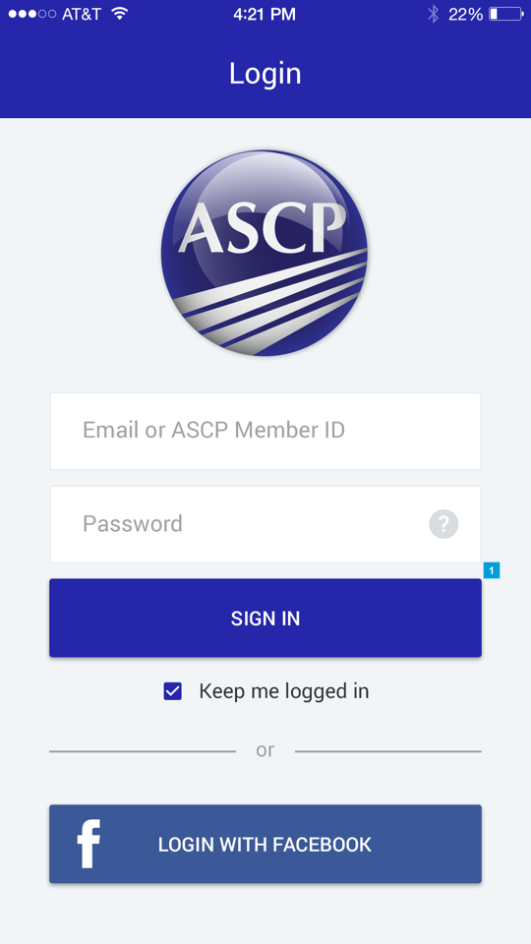

* 1. Widget Table

|  |  |
| --- | --- |
| Footnote | Note |
| 1 | Upon successful login, take user to Dashboard |

1. Dashboard
   1. User Interface

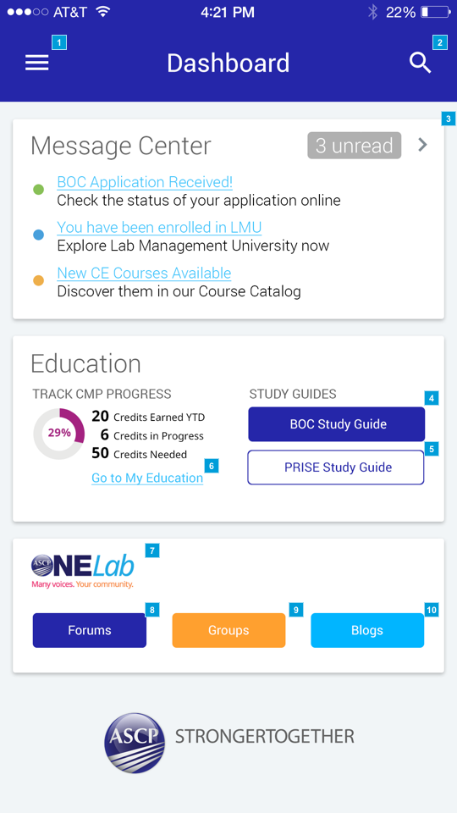

* 1. Widget Table

|  |  |  |
| --- | --- | --- |
| Footnote | Name | Note |
| 1 | Hamburger Menu slides in from left On Click | On Click, take user to Hamburger Menu  - If user is a member, take to Hamburger Menu - Members  - If user is non-member, take to Hamburger menu - Non-Member |
| 2 | Hamburger Menu slides in from left On Click | On Click, take user to Search Screen |
| 3 |  | On click, take user to Message Center. Message titles, New Message Counter (3 unread) and arrow are clickable to Message Center |
| 4 |  | On Click, take user to BOC Study Guide |
| 5 |  | On Click, take user to PRISE Product page (URL to be provided by ASCP IT Dept) |
| 6 |  | On Click, take user to My Education Screen |
| 7 |  | On Click, take user to BOC Landing Page |
| 8 |  | On Click, take user to external webpage (display within app in a webview) http://labculture.ascp.org/community/forums |
| 9 |  | On Click, take user to external webpage (display within app in a webview) http://labculture.ascp.org/community/groups |
| 10 |  | On Click, take user to external webpage (display within app in a webview) http://labculture.ascp.org/community/blogs |

1. Hamburger Menu - Members
   1. User Interface

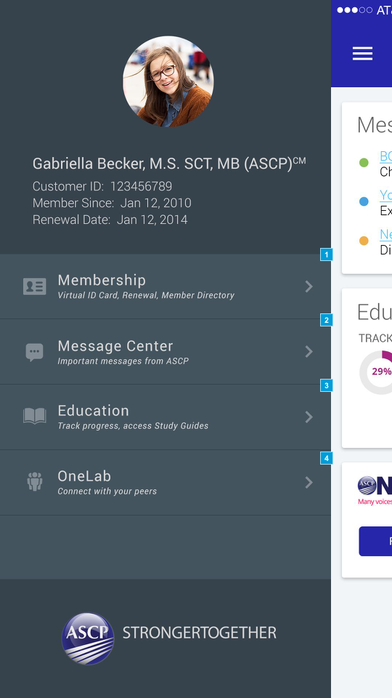

* 1. Widget Table

|  |  |  |
| --- | --- | --- |
| Footnote | Name | Note |
| 1 | Hamburger Menu slides in from left On Click | On Click, take user to Membership Screen |
| 2 | Hamburger Menu slides in from left On Click | On Click, take user to Message Center |
| 3 | Hamburger Menu slides in from left On Click | On Click, take user to external webpage (display within app in a webview) Post Login My Education page) |
| 4 | Hamburger Menu slides in from left On Click | On Click, take user to external webpage (display within app in a webview) OneLab homepage |

1. Hamburger Menu - Non-Members
   1. User Interface

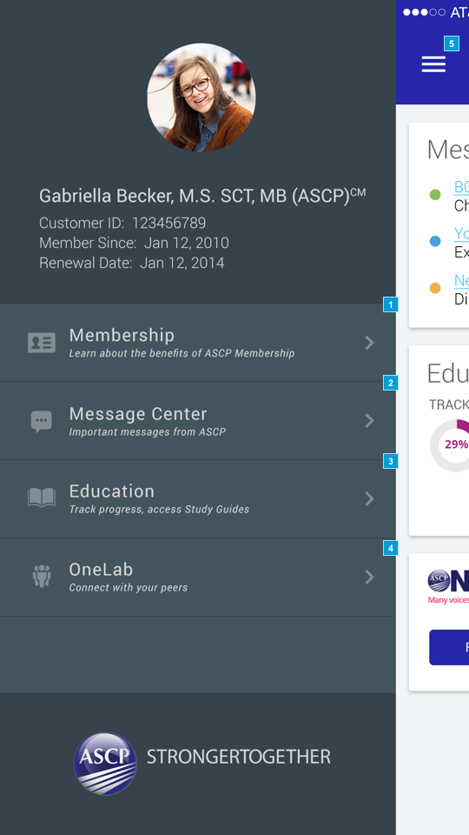

* 1. Widget Table

|  |  |  |
| --- | --- | --- |
| Footnote | Name | Note |
| 1 | Hamburger Menu slides in from left On Click | On Click, take user to Become a Member Screen |
| 2 | Hamburger Menu slides in from left On Click | On Click, take user to Message Center |
| 3 | Hamburger Menu slides in from left On Click | On Click, take user to external webpage (display within app in a webview) Post Login My Education page) |
| 4 | Hamburger Menu slides in from left On Click | On Click, take user to external webpage (display within app in a webview) OneLab homepage |
| 5 |  | On click close hamburger menu |

1. Search
   1. User Interface

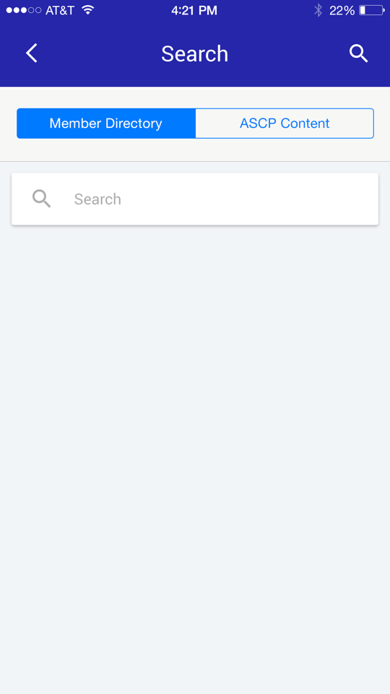

1. Message Center
   1. User Interface

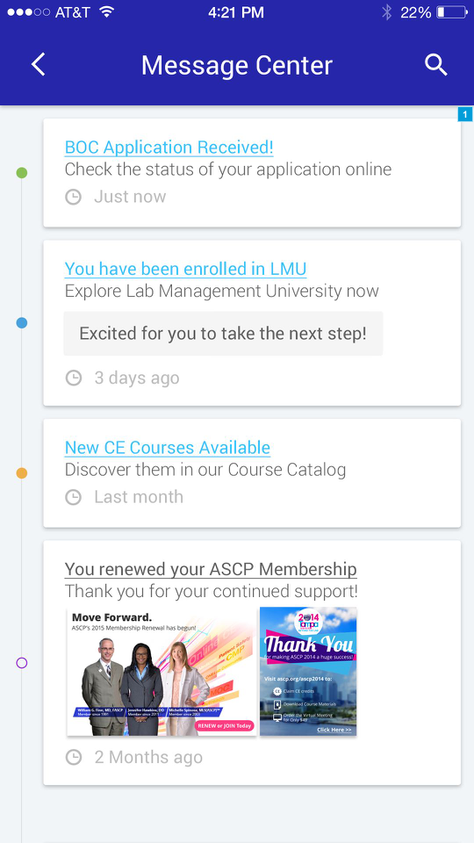

* 1. Widget Table

|  |  |
| --- | --- |
| Footnote | Note |
| 1 | When Message card is clicked, take user to Message View |

1. Message View
   1. User Interface

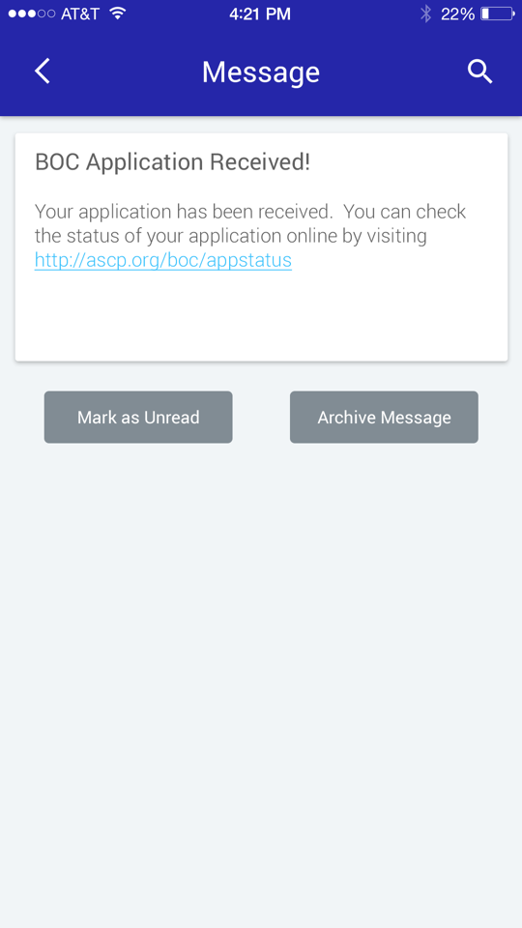

1. My Education
   1. User Interface

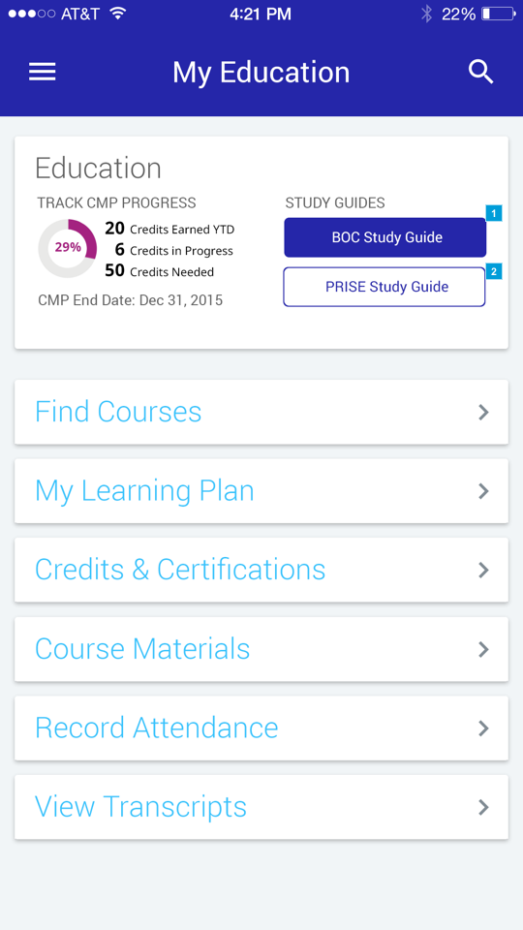

* 1. Widget Table

|  |  |
| --- | --- |
| Footnote | Note |
| 1 | On Click, take user to BOC Study Guide |
| 2 | On Click, take user to PRISE Product page (URL to be provided by ASCP IT Dept) |

1. Study Guide Home
   1. User Interface

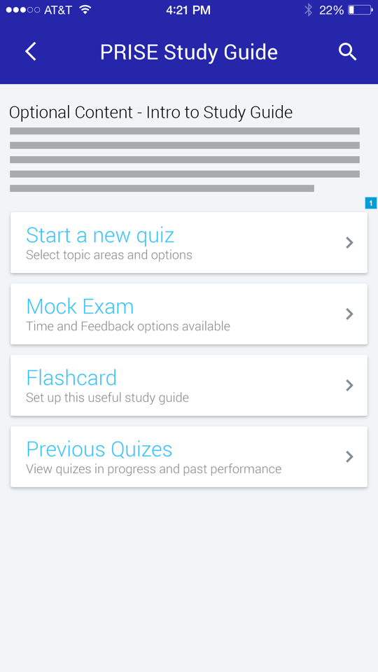

* 1. Widget Table

|  |  |
| --- | --- |
| Footnote | Note |
| 1 | Take user to Study Guide Modules |

1. Study Guide Modules
   1. User Interface

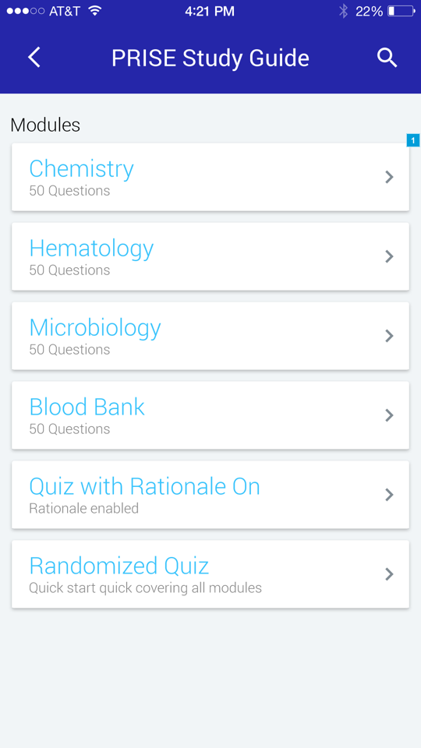

* 1. Widget Table

|  |  |
| --- | --- |
| Footnote | Note |
| 1 | When Module is Clicked, take user to Study Guide Quiz Settings |

1. Study Guide Quiz Settings
   1. User Interface

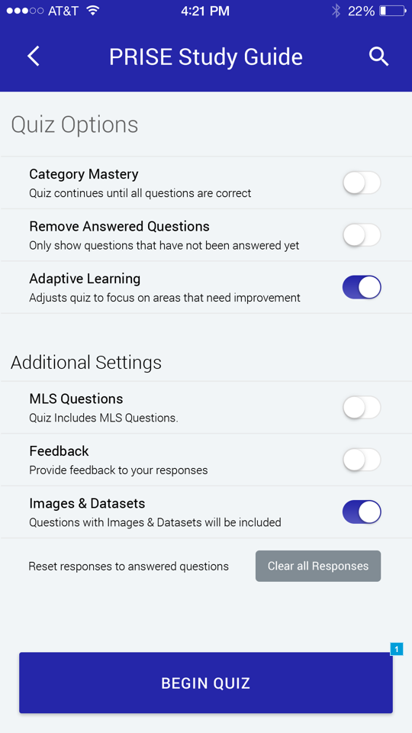

* 1. Widget Table

|  |  |
| --- | --- |
| Footnote | Note |
| 1 | On Click take user to Study Guide Question |

1. Study Guide Question
   1. User Interface

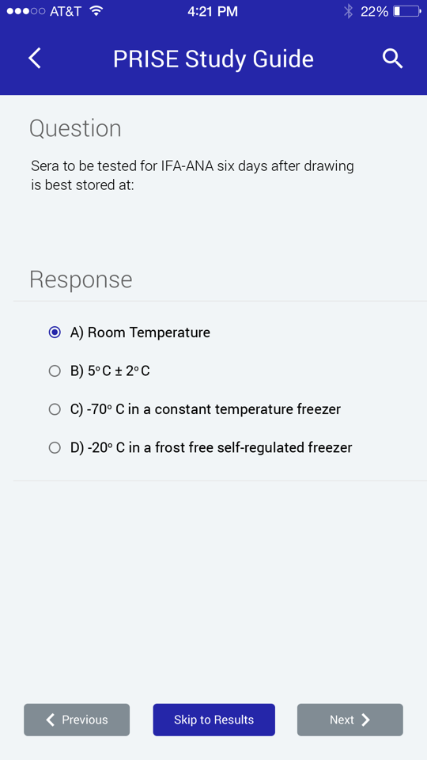

1. Study Guide Feedback
   1. User Interface

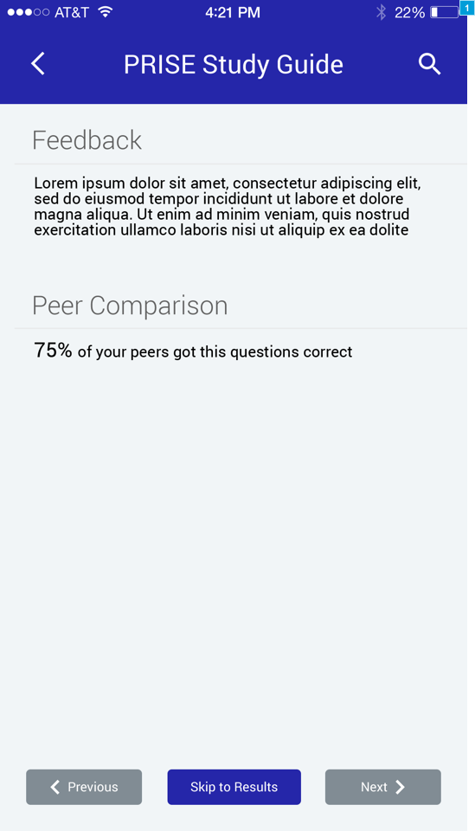

* 1. Widget Table

|  |  |
| --- | --- |
| Footnote | Note |
| 1 | This screen is shown after a question is answered if the feedback Quiz option is selected |

1. PRISE Product Page
   1. User Interface

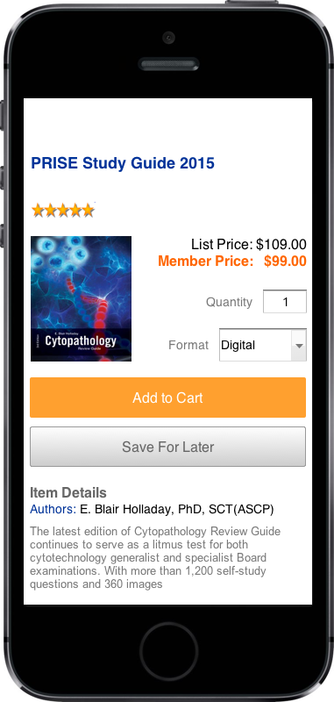

1. Membership
   1. User Interface

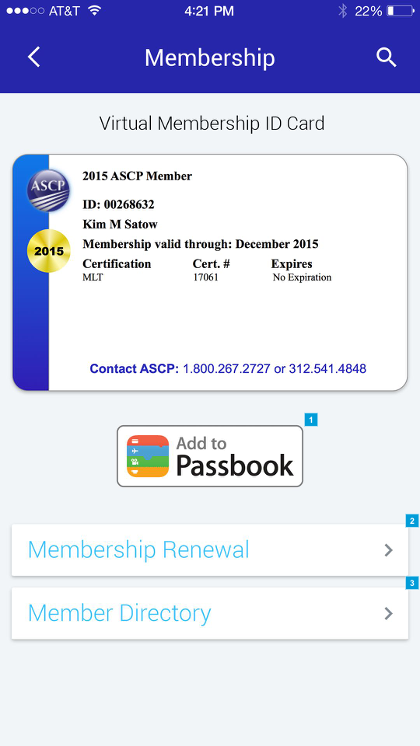

* 1. Widget Table

|  |  |
| --- | --- |
| Footnote | Note |
| 1 | On Click add Member ID to passbook and take user to Passbook Screen |
| 2 | On Click take user to Membership Renewal |
| 3 | On Click take user to Member Directory |

1. Become a Member
   1. User Interface

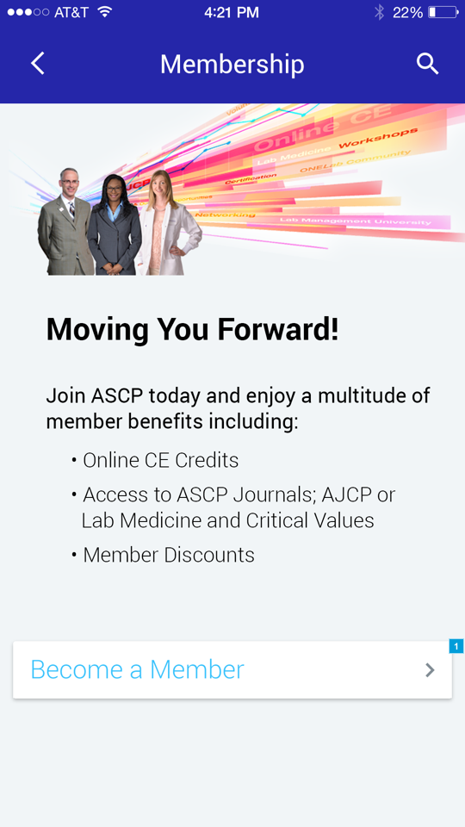

* 1. Widget Table

|  |  |
| --- | --- |
| Footnote | Note |
| 1 | On Click take user to Become a Member Flow |

1. Passbook
   1. User Interface

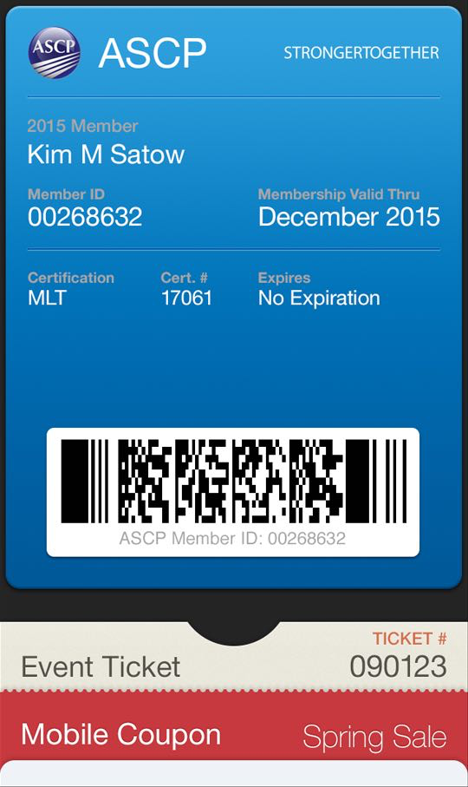

1. Member Directory
   1. User Interface

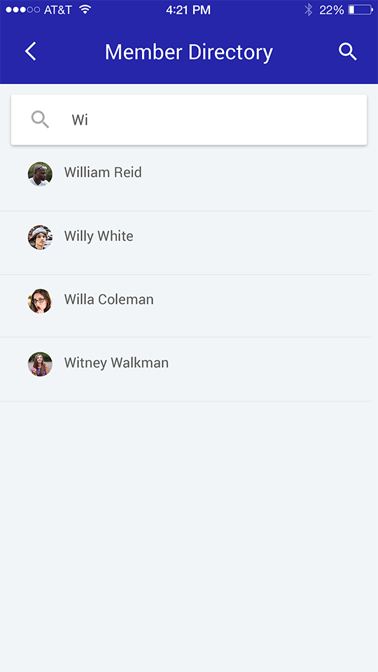

1. Membership Renewal 1
   1. User Interface

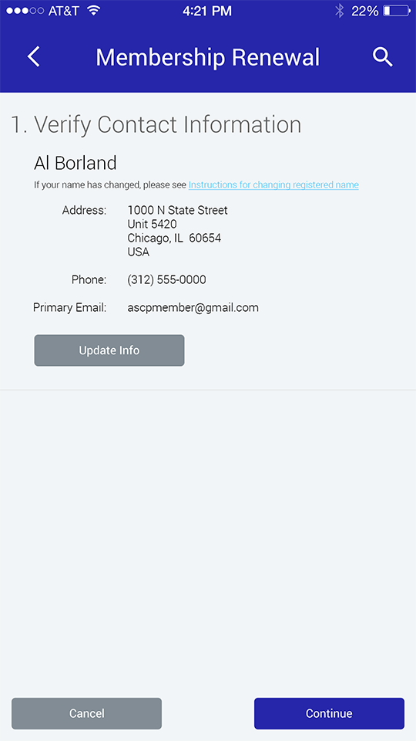

1. Membership Renewal 2
   1. User Interface

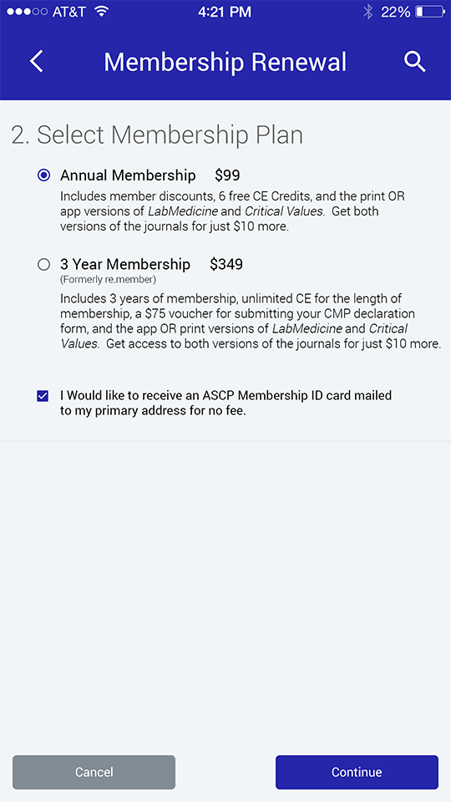

1. Membership Renewal 3
   1. User Interface

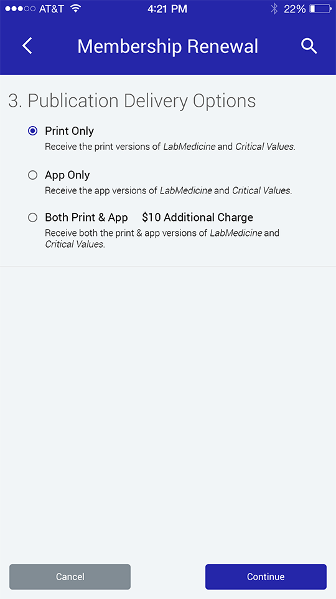

1. Membership Renewal 4
   1. User Interface

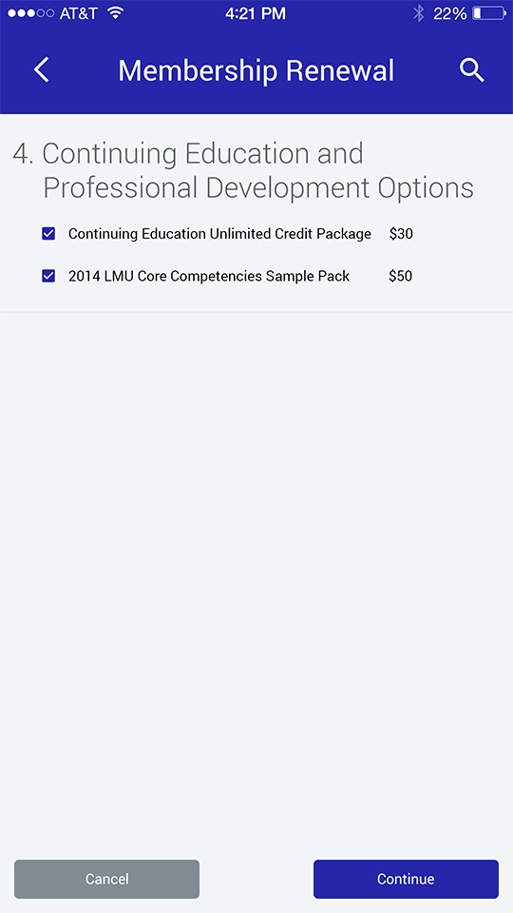

1. Membership Renewal 5
   1. User Interface

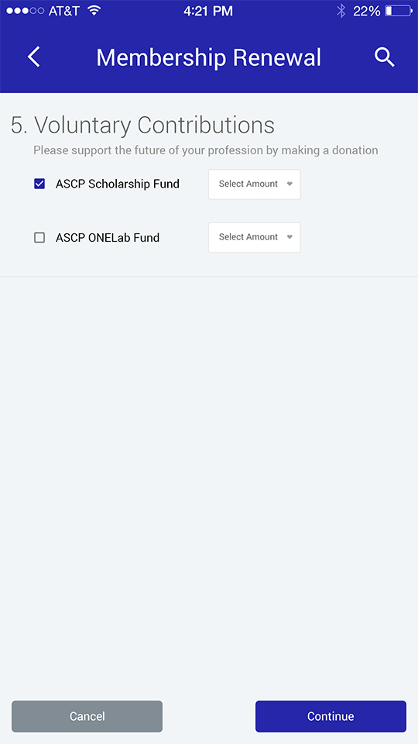

1. Membership Renewal 6
   1. User Interface

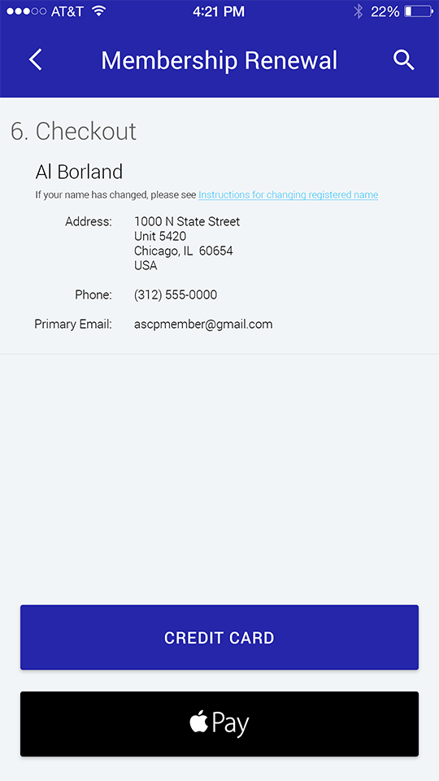

1. Membership Renewal 7
   1. User Interface

